Shabbat in the Forest
Soon The Good Shabbat
Will Come To Us.
[Shmuel Bass]

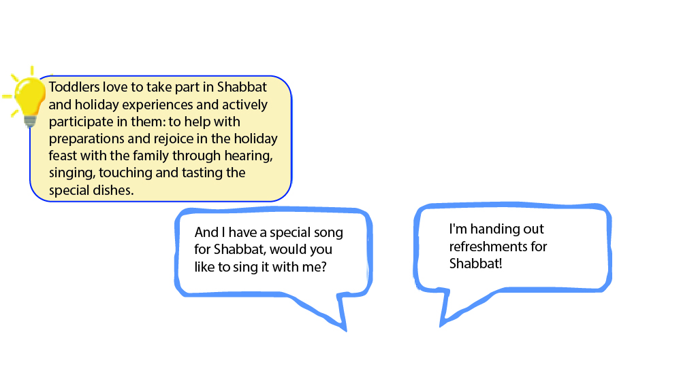
The turtle invited his friends over to welcome the Shabbat, and the excitement in the forest is in full swing. Like the turtle preparing for Shabbat with shopping and cooking delicacies, and like its friends waiting to welcome the Shabbat together, so are the toddlers excited for Shabbat and the holiday. They join and participate in rituals and celebrations and experience them through actions, stories, tastes and smells.

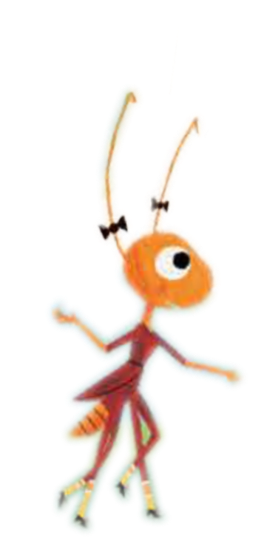

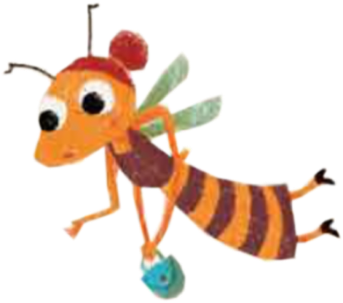

Reading Together – Experiencing Together

Reading Together You can encourage the toddlers to actively join in reading the story. They can complete rhyming words, accompany the conversation between the animals with facial expressions and proper hand gestures, and make the sounds of the animals appearing in the story.

Towards welcoming Shabbat
You can ask the toddlers: What do you like to do on Shabbat? If the family has special preparations for Shabbat, it is worthwhile to tell and share them with the toddler

Where Are The Animals?
The book features a bee, a turtle, an ant, a chicken, a cow and a rabbit. Ask the toddlers to identify the various animals in the illustrations in the book and accompany each animal with its unique voice or add other characteristic detail: the bee hums, the rabbit bounces, the turtle crawls slowly, and the cow is mooing.

And Now - A Turtle!
How to make a turtle with the palm of your hand? Close the palm to a fist and hide the thumb inside. Call the turtle out, take out the thumb and wave it hello. You can create a bunch of turtles with all the palms present at home You can also be a turtle yourself and walk slowly on all fours. Are you tired? Get inside to rest in your "home".

QR - Want to listen to the story? - Scan the code and listen to "Shabbat In The Forest".
Pinterest – Crafts, songs and other activities on the "The Shabbat In The Forest" book page in Sifriyat Pijama on Pinterest

