A book about A hand

I have fingers, ten of them
There's nothing they can't do:
They can paint and they can draw,
Beat upon the drum, too!
(“I have ten fingers”, Rivka Davidit)

Toddlers discover their hands as part of their journey to discover themselves and the world. They discover that they can clap their hands and play music, they can “talk” with their hands, build and play games. In the imagination games of toddlers, hands can fly and run, swim or grow leaves and branches. “A book about A hand” invites adults and little children to participate in finger games of magic and imagination, to read and play as a shared family fun activity.
The game contributes to the development of toddlers, It enables them to learn. and deepen relationships with family members and friends in an enjoyable, creative manner. Initially toddlers play by mimicking adults. Gradually they develop their own imaginary games based on imagination.
and I want to play too!
Quack, quack, quack, I am a duck
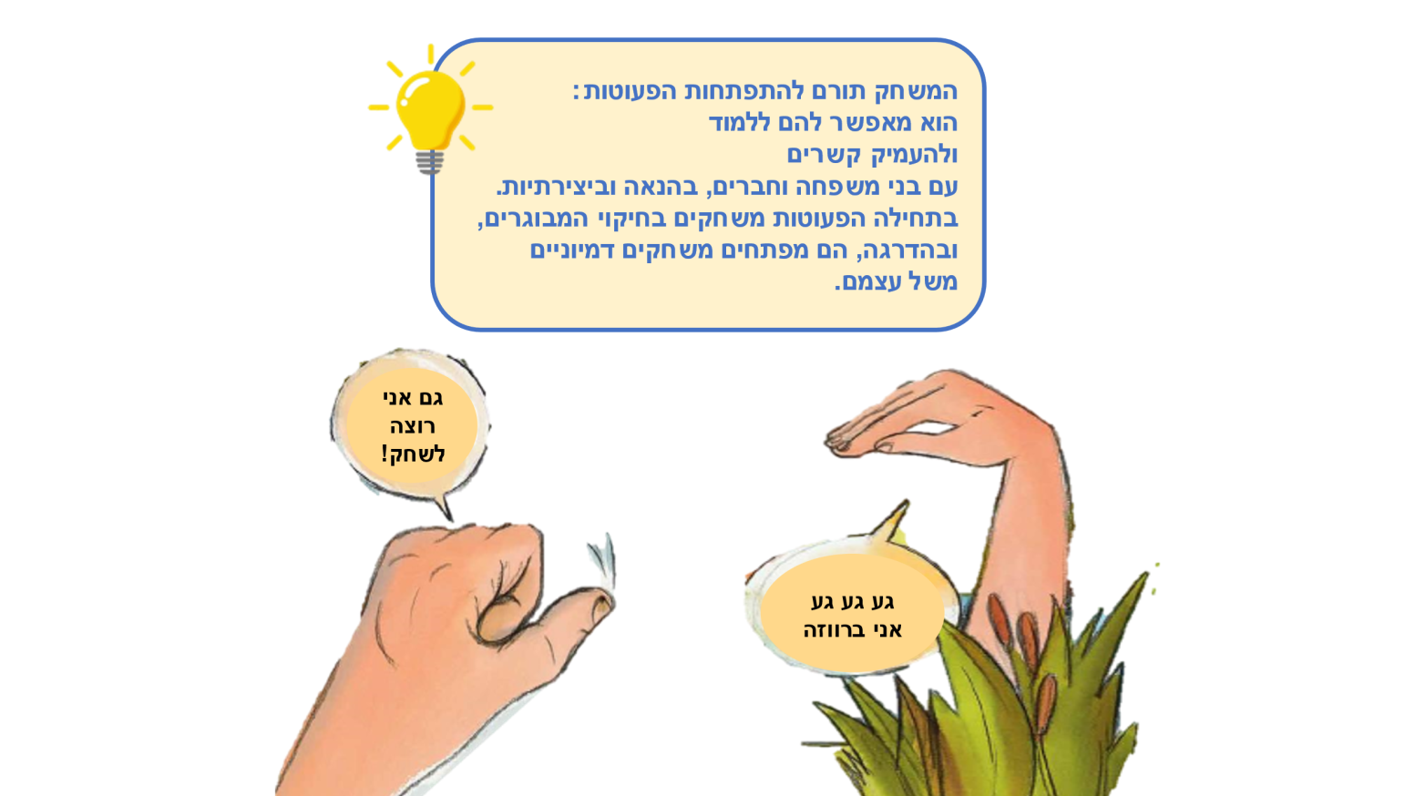
Копию этих страниц на русском языке можно найти в русской части нашего сайта www.splk.org.il

Reading together –Experiencing together

Reading together
While reading, it is useful to include the hands on each page, follow their path and imitating their movements. Parents and toddlers can do this together: “walk” the hand on fingertips, make the hand jump, knock on the door in the picture, and be active readers throughout the entire book.

Hand Games
It’s so much fun to play with hands! Each and every one in turn makes a certain movement, and the rest of the participants imitate it. You can clap your hands, wave hello or goodbye, signal for "quiet" or fly!

A Family of Hands
Who has a small hand? Who has a large hand? Each family member is invited to place their hand on a sheet of paper. You, the parent, will draw the contours of the hands, and the toddlers will decorate and paint. The picture of all the hands can be kept as a memento, and you can also repeat the activity year after year and see what has changed.

Singing Hands
You can sing songs accompanied by hand movements, such as “I have ten fingers” or “My hat has three corners.” It's a good idea to add hand gestures to your singing, and you can add finger movements to other favorite songs. Have fun!

QR – Story-game using fingers is waiting for you when you scan the code. Take a look and enjoy!
Pinterest – Crafts, songs, and activities in the Sifriyat Pijama's Pinterest page.

