Who wants to taste? (TIRTZU LIT'OM? )
Toddlers love to feel like they're independent and mature. Slowly, the toddler develops and begins to share with others, consider and offer help. The book “Who wants to taste?” (TIRTZU LIT'OM?) presents the world of a toddler who learns to give, and thus discovers new possibilities of connection and giving that strengthen ties and expand the heart:
A man’s gift maketh room for him
[Proverbs 18:16]
Toddlers learn about sharing and collaborating when adults demonstrate the actions, include the toddlers in the activities and allow them to share gradually, and at a pace suitable for each one of them.

Can you hand out the cookies? Thank you!

I can help too!
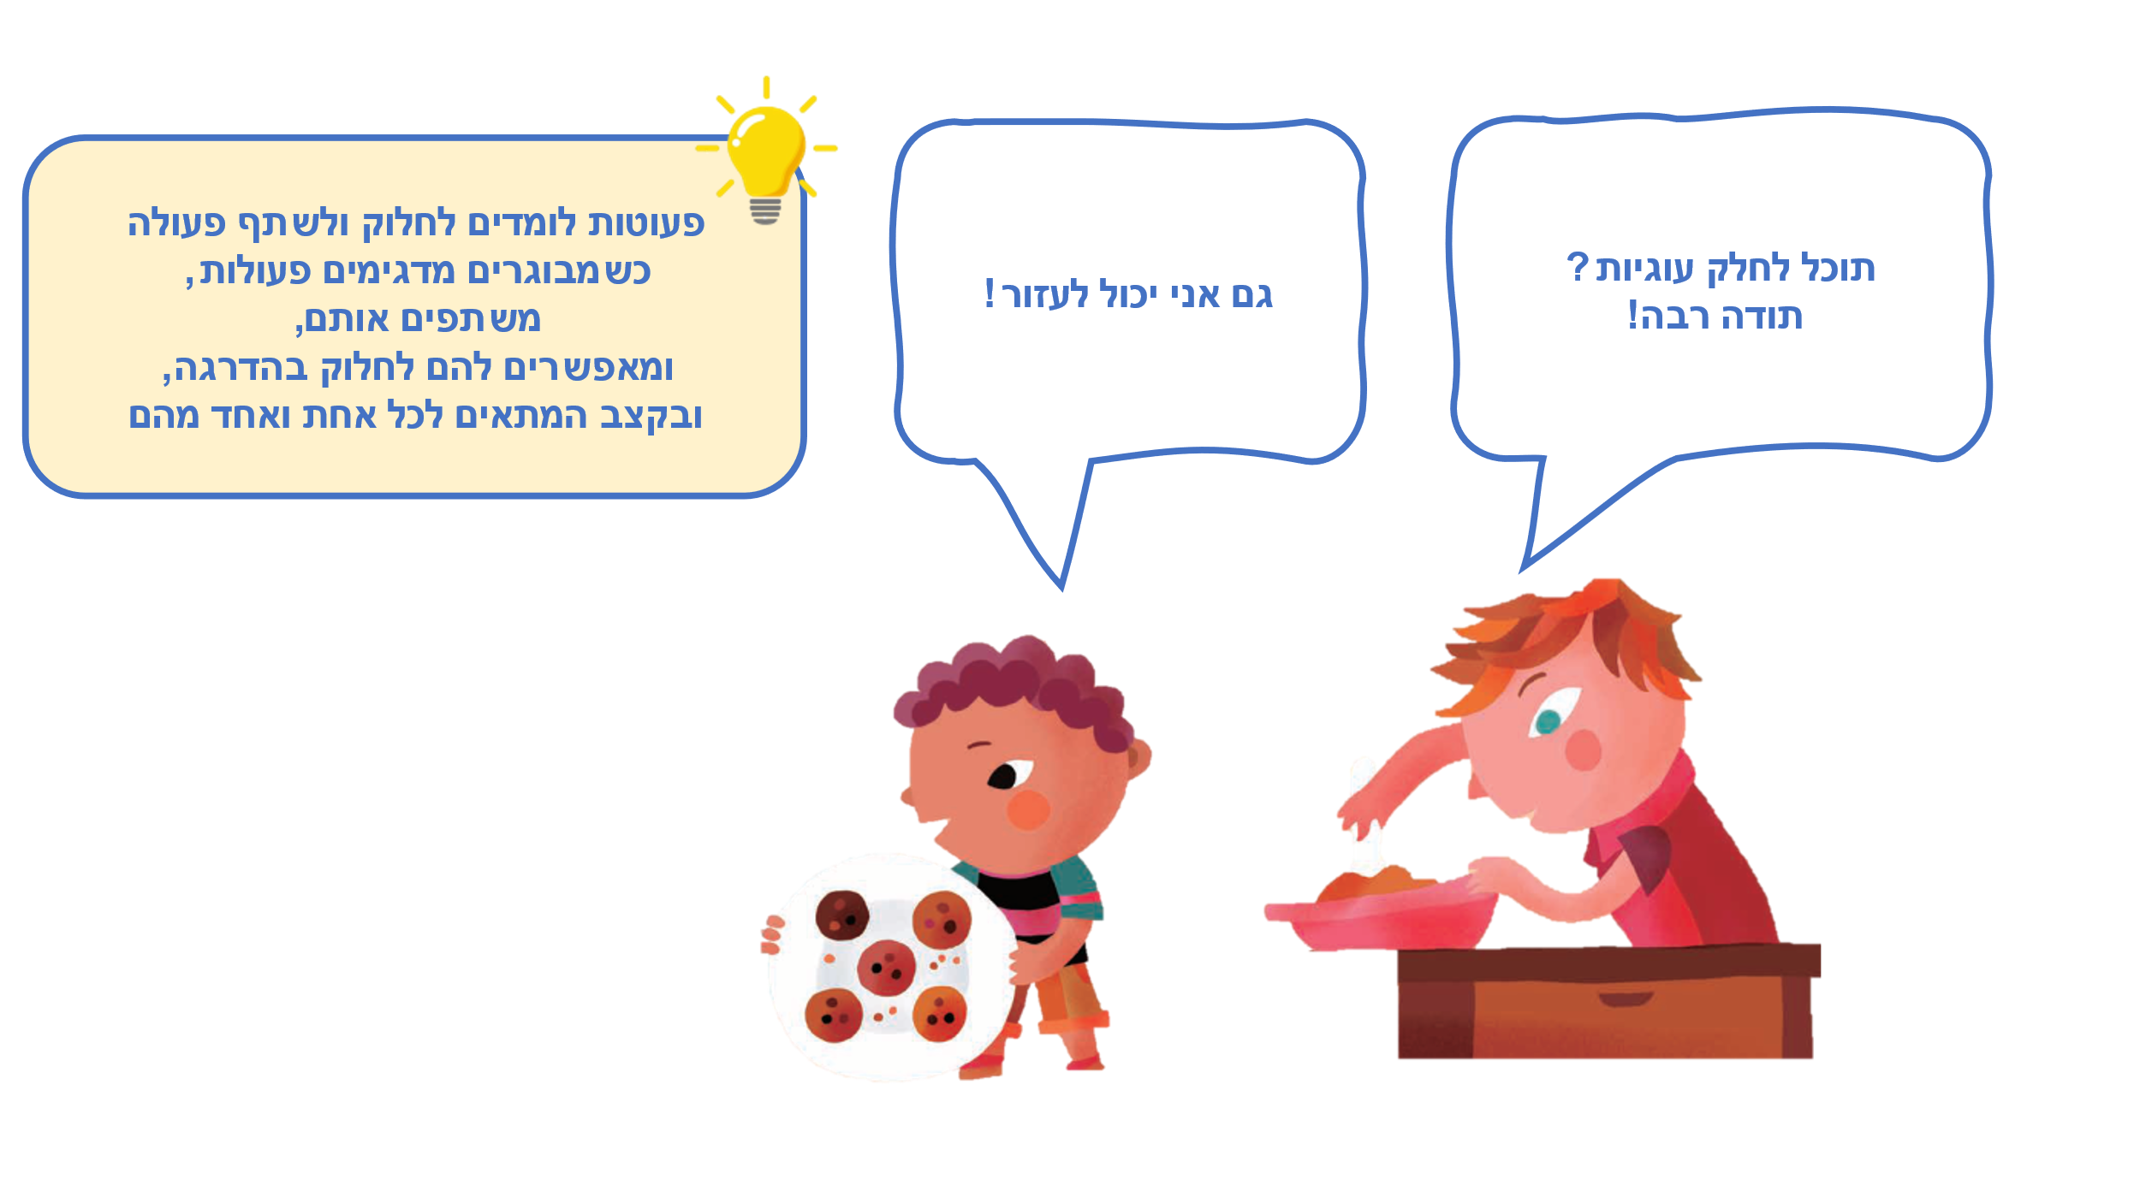

Reading together –Experiencing together

We can help too!
What can toddlers do at home? Many things! They can put glasses on the dining table, sweep with a small broom, feed the pets, and... offer cookies. It is worthwhile to talk and show what the toddler is helping with at home, and what else they want and can participate in.

Who is in the family?
The child in the story hands out cookies to other family members: grandmother, uncle, sister, cousin. Who are your family members? You can talk about family members, say their names and thier roles, such as: “Grandma Braha,” “Uncle Baruch,” use family photo, and use family photos.

Let’s make some refreshments together!
You too can prepare refreshments together, such as chocolate balls, a plate of fruit, or a sliced cucumber. You can prepare "pretend" refreshments using play dough and offer to the dolls at home.

Game: Grandma had cookies…
Do you know the game “Grandma made porridge”? “The child had cookies” can be played in a similar way, in which the toddler opens her, or his hand, and the parent begins to count: “The little boy/girl had cookies and gave one to Grandma (holding the thumb), and one to Uncle (holding the forefinger) etc. And so you count the fingers by allocating a family member to each one. Who will you give the last cookie to?

QR – Would you like to play at handing out cookies? Scan the code and you play this game with the toddler.
Pinterest – Crafts, songs, and activities on the “Who wants to taste?” page in the Sifriyat Pijama (ספריית פיג'מה) on Pinterest

