

**I Sat On a Cabbage**

It’s fun when we have friends, it’s pleasant and good.

It’s fun to play side by side when everyone's playing their own game,

This is the first step of connecting with friends.

Later the ability to become a friend develops:

Share and play together with each other.

**...how good and how pleasant it is for brothers to dwell together in unity!**

**[Psalms 133:1]**

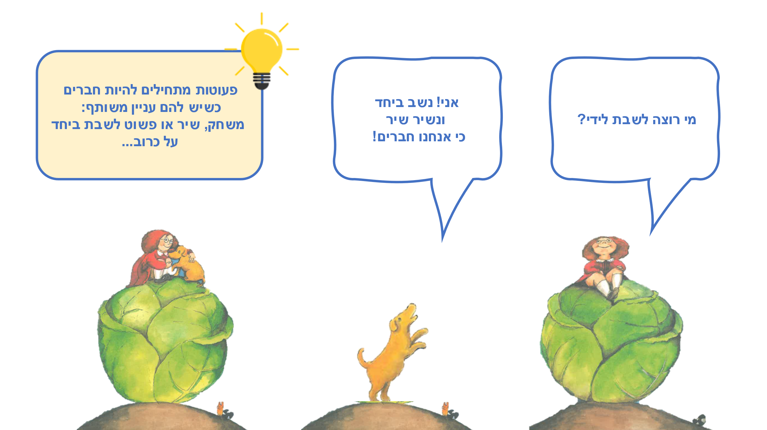

|  |  |
| --- | --- |
| Who wants to sit next to me? | מי רוצה לשבת לידי? |
| Me! Let’s sit together and sing together because we’re friends! | אני! נשב ביחד ונשיר שיר כי אנחנו חברים! |
| Toddlers begin to become friends when they share a mutual interest with another person: a game, song, or just sitting together on a cabbage… | פעוטות מתחילים להיות חברים כשיש להם עניין משותף: משחק, שיר או פשוט לשבת ביחד על כרוב... |

Копию этих страниц на русском языке можно найти в русской части нашего сайта [www.splk.org](http://www.splk.org).il

**Reading together –Experiencing together**

**Reading and hugging**

While reading a story, you can hug each time a new animal joins the group. You can also play the hugging game: move away from each other, count "three, four," and then run to each other, and hug!

**It’s crowded but that doesn’t matter!**

Invite the rest of the family to sit together with you on the couch, on the carpet or on a mattress. You can also include dolls or pets. Sit close together, then further away, and check: how pleasant is the closeness?

**What sound do I make?**

How does a dog bark? How does a cat meow? and how does a cow moo? – Toddlers can join can join in to the animals in the story.

Would you like to bring another animal in? And what sound would that animal make?

**Sing about cabbage**

“I sat on a cabbage” is a song that you can sing, add movements to, dance to and clap your hands to.

The song will upload when you scan the code:

**QR** –  [I Sat On a Cabbage](https://www.youtube.com/watch?v=pGGWhhfceJE) – Scan the code and sing together!

[Pinterest](https://bit.ly/30HXzLA) – Crafts, songs and activities on the “I Sat On a Cabbage” book page in Sifriyat Pijama's Pinterest site.