Grandpa's Pockets – For Families
Why do we need a clock? And what do we do with seeds?
Toddlers are curious and ask lots of questions and the answers teach them about the world. A good connection with adults allows toddlers to ask questions, receive answers, and learn in a joyful way at a pace that suits them. They will find surprises of love and attention, in the spirit of the words:
Ask your father and he will tell you, ask your elders and they will explain to you.
[Deuteronomy 32:7]
Relationships with adult members of the family contribute to the emotional and mental development of toddlers and to their sense of belonging and resilience.

What are we going to do today, Grandpa?
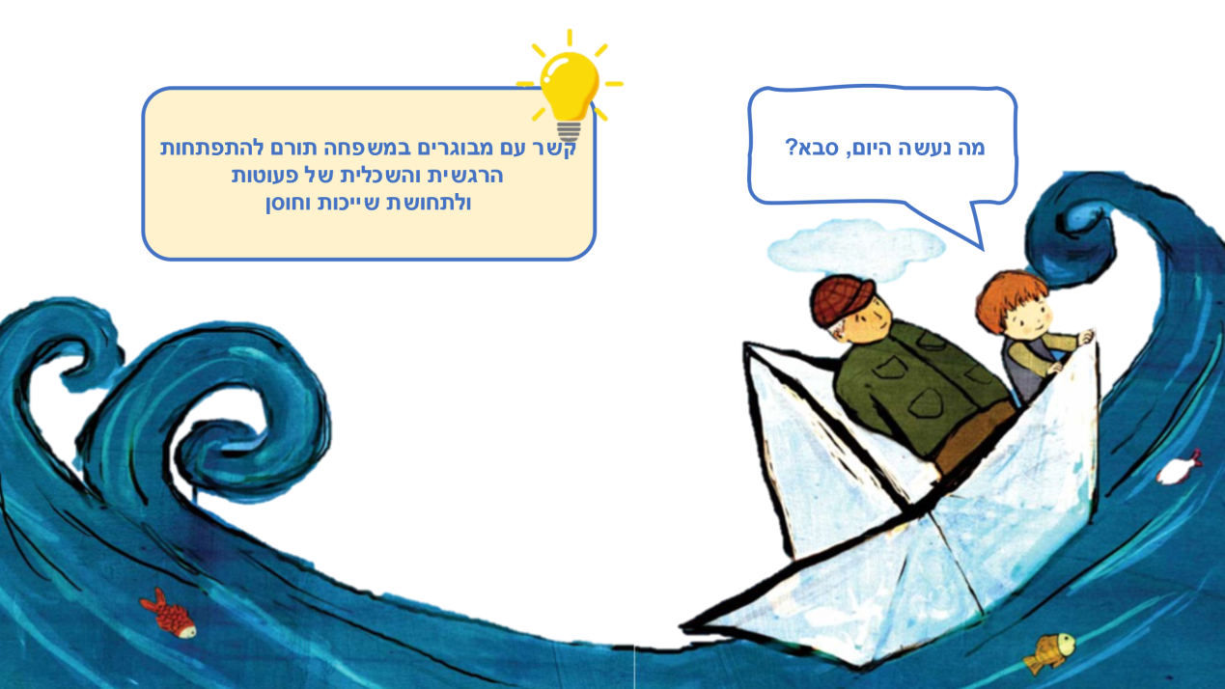

Reading Together – Experiencing Together

Reading Together
It is worth sharing the reading of the story with the toddlers: Where is the key? What do you do with the string, and what are the crumbs for? What surprise is hiding in the small pocket?

Guessing Game
Hide an object in a garment pocket and let the toddler guess what you hid with the sense of touch. You can provide clues, reveal a fraction of the object, and eventually disclose the item and demonstrate what it is used for.

Doing Things Together in the Family
Grandfather and the child are talking, sowing seeds, and feeding the rabbit. What do toddlers love to do with adults in the family? With grandparents and other family members?

What Goes with What?
“A key in order to open”; “A ticket to ride the train”; and what is a basket for? Or a spoon? You can walk around the house and choose items, then talk and check together what they are called and what they are used for. Matching Game –What Belongs to What – is waiting for you when you scan the code:
QR – Scan to download the game “Who Belongs to Whom”

Pinterest – Crafts, songs and other activities on the “Grandpa’s Pockets” book page in Sifriyat Pijama on Pinterest

