The holidays, seasons and me
“And you shall rejoice in your festival, and you shall have nothing but joy”
(Deuteronomy 16:14-15)
The year begins with the arrival of autumn. On Pessach it is spring is blooming. On Shavuot (Feast of Weeks) we celebrate in harvest days. Toddlers experience the tastes of the holiday and the changing periods, such as the first rain, the hum of the wind, and the light of the holiday candles. They share the joy felt by family and community, and songs are part of this commonality.
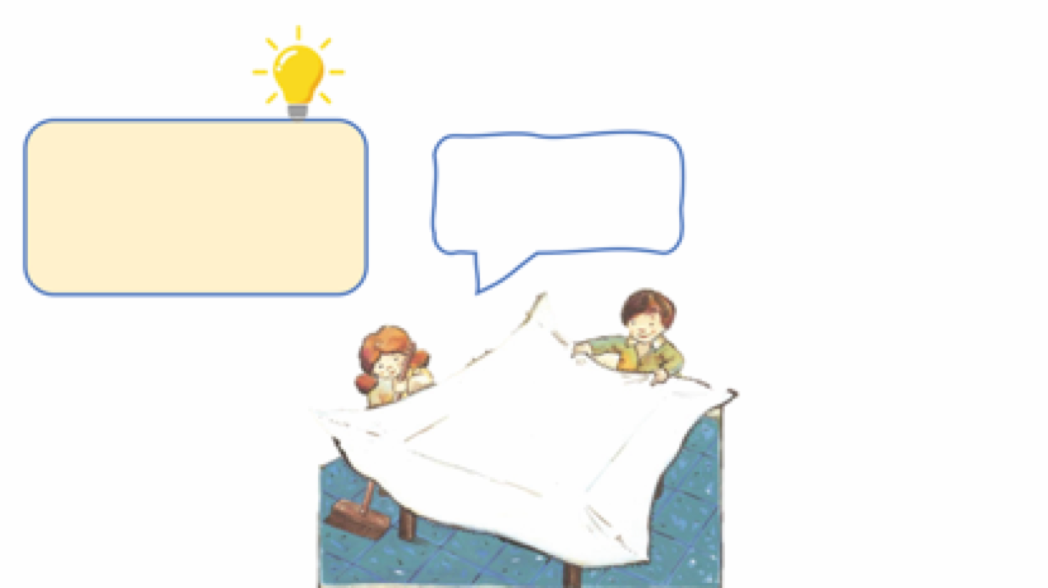
We help organize and get ready for the holiday!
Actively participating in preparing for the holiday’s festive events adds to the toddlers’ excitement and joy, and teaches them about the holiday while contributing to their senses of belonging and capability.

Songs for all Times
This book is a gift that can accompany you as a family throughout the year: on festive holidays and in changing seasons, with the arrival of Autumn and in preparation for a birthday celebration. Choose the appropriate song for each coming occasion or holiday, read it together, look at the illustrations, sing and celebrate. Poems and illustrations Read the songs together and look at the illustrations. Which illustrations attract the children's attention?

Songs and Illustrations
Read the songs together and study the illustrations. Which illustrations draw the children’s attention?
You can look together at what you see in the illustration and what details appear in it.

Words and Melodies
Many of the songs in this book were composed to music. You can take a cymbals, wooden spoons or lids of pots and pans, and accompany the singing by playing music and dancing. Once the children are familiar with the song, you can play a guessing game: starting humming the tune, and invite the children to guess the rest and join you.

What’s Hiding in the illustration?
Open the book randomly, or at a favorite song, and let each person in turn name an item that everyone else must look for in the illustration: Find in the illustration: Where is the house with a red roof? Where is the pomegranate? Where are the clowns?

QR – How do we celebrate with the little ones? Scan the code and watch the clip-on involving toddlers in the festivals.
Pinterest – Ideas for crafts and activities centered around the holidays, songs composed to melodies and more, are waiting for you on the book’s page in Sifriyat Pijama's Pinterest site.

