Elik Belik
Like many other toddlers, Yaeli plays imagination games and creates her own magical world. Yaeli's parents enter the world of their daughter's imagination and understand that play is Yaeli's way of expressing her imagination and creativity, expressing joy and longing, and thus expressing the ancient idea -
Teach a Child According to His Way
(Proverbs 22: 6)

Копию этих страниц на русском языке можно найти в русской части нашего сайта www.splk.org.il

የእነዚህን ገጾች የአማርኛ ትርጉም በፒጃማ ቤተ መጽሐፍት በአማርኛው ክፍል ውስጥ ማግኘት ይቻላል: www.splk.org.il
The game is an expression of the imagination of the toddlers, helping them express emotions, feel that they are in control of what is happening around them, and strengthen relationships with family and friends.
Here is my friend!!!
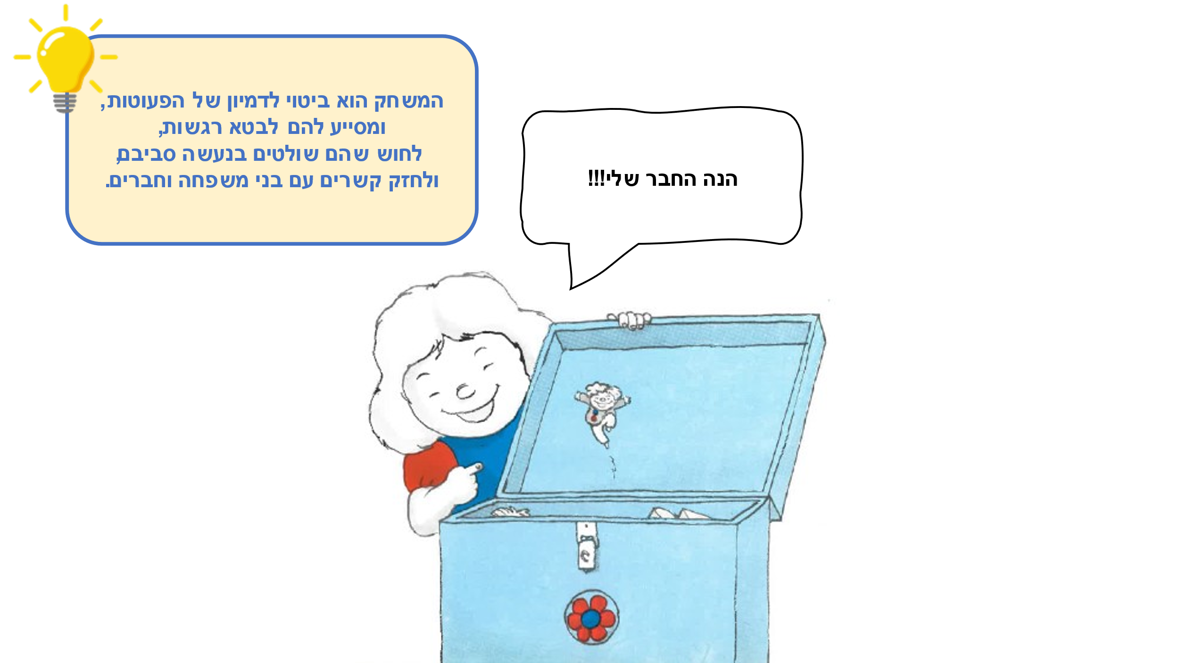

(It should be)
Feel
around them and strengthen
Reading Together – Experiencing Together

Reading Together
Do you also have little friends visiting your home? Are they imaginary friends, or maybe a beloved doll? It is worthwhile to talk about it with the toddlers and hear what do they like doing with the little friend. You can "bring in" the little friend to join and read the story.

How to Read the Story? The story is slightly longer than usual, and in order to arouse interest and curiosity it is recommended telling it in a variety of voices: a voice for Dad, a voice for Yaeli and a different voice for Mom and for Elik Belik. You can look together at the illustrations and invite the toddlers to participate in the identification of details and repeat the words "Elik Belik".

Hide and Seek
Where's the doll? On the table? maybe underneath it? And where's the ball? You can hide various objects, look for them and then say: "The ball is on the chair", "The ball is under the bed". You can also hide yourselves and look for each other.

From Small to Big
Dad has big shoes, Mom's shoes – they are less big, Yaeli has little shoes, and Elik Belik's? Tiny shoes! Go on a journey throughout the house, collect items of the same type and arrange them from the smallest to the biggest.

QR - Scan the code and listen to the story with the kids!
Pinterest - Crafts, songs and other activities on the "Elik Belik" book page in Sifriyat Pijama on Pinterest

