Where to, Where to? To kindergarten!

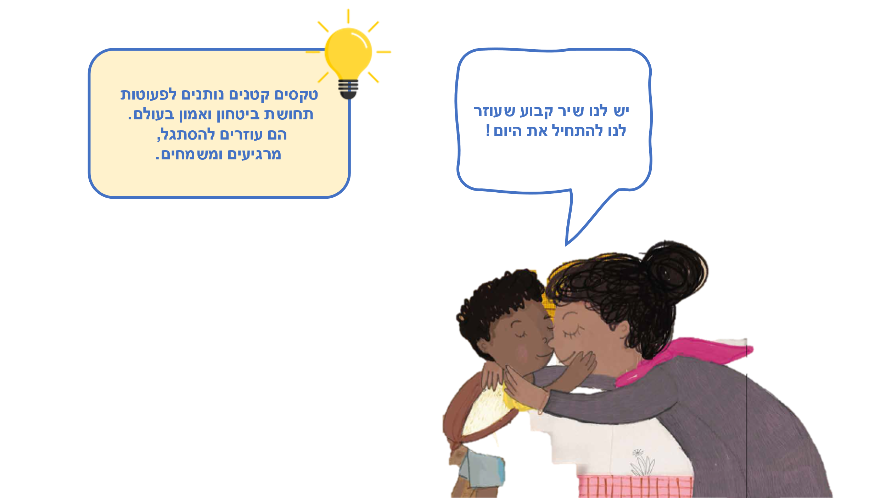
We’ve got a song we can sing that helps us start the day! Go have a regular song that helps us start the day! a sense of security and trust in the world. | יש לנו שיר קבוע שעוזר לנו להתחיל את היום!
Small rituals give toddlers a sense of security and trust in the world. | טקסים קטנים נותנים לפעוטות תחושת ביטחון ואמון בעולם.
They help them adapt, relax, and rejoice. | הם עוזרים להסתגל, מרגיעים ומשמחים.

A new day has begun!
On happy days, and even on days that are a bit difficult,
a favorite song can fill the heart with joy
and make us really want to go – Where will I go? To kindergarten!

The educator, Yanusz Korczak believed that morning is a special time when every boy and girl chooses to start the day in the way that suits them best:
In the morning, don’t grudge him the time for a story, for a chat with his dog, for catching ball, for the careful study of a picture, or for copying letters. Allow time for this with kindness. The child is really right in this.
[Janusz Korczak, The Child’s Right to Respect, pg. 37]

Reading together –Experiencing together

Reading, Singing and Moving
Let the toddler complete the repeating sentence: “Where to, where to? To kindergarten!”
You can add movements, clap hands or use musical instruments.

Our Morning Ritual
A fixed set of morning actions helps toddlers start the day well:
Prepare the clothes together, sing an encouraging song, collect leaves or a twig along the way, or say goodbye with a fixed, encouraging greeting.

Illustrations "Tell a Tale"
Look together and let the toddler find: Where is the bird? Is it on additional pages? Who accompanies the child to kindergarten? How do we get to kindergarten – by bicycle, walking or some other way? Who wears a hat and where is the dog?
Look at the last page and ask: “What are the children in kindergarten doing? What do you like to do at the nursery?”

Game: Where to?
Ask: Where to, where to? And each time choose a different place: To… The bath, the balcony, or to… The playground? Go together to the place you’ve chosen, hug each other and then say aloud: Where to, where to? To… the next place!

QR Why Sifriyat Pijama?
Because it’s not just a book – it’s an opportunity to be together!

Pinterest – Crafts, songs and activities on the “Where To? Where To? To Kindergarten!” on Sifriyat Pijama's page on Pinterest

