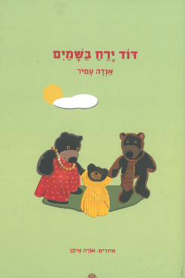
דוד ירח בשמיים
כתבה: אנדה אמיר איירה: אורה איתן
תרגום לאנגלית של ההצעות לפעילות בחיק המשפחה

Uncle Moon in the Sky – Collected Poems
By Anda Amir
Illustrated by Ora Eitan

This collection of poems introduces children to characters and objects in their world: toys and dolls, animals, near and far landscapes, etc.
Anda Amir's poems have been a source of joy for generations of Israeli children, and have become true literary assets. Some of them have also been put to music. We hope you and your child enjoy hours of shared reading, reciting, and singing.

Anda Amir (1902–1981)
Israeli children's poet and author, Anda Amir, was born in Poland, and immigrated to Israel in 1920. She wrote many children's poems that accompany Israeli children to this day, among them The Hedgehog
Wanted to Dance, The Sparrow, and Golden Ship. For her numerous stories and translations Amir was awarded the Bialik Award in 1936, and the Israel Prize in 1978.

Proposed Family Activities

- A different kind of reading
Reading a poetry book and a storybook is not the same. The poems included in this collection are short and catchy, and you may enjoy reading them over and over again. You could invite your child to leaf through the book, and select a different poem each time. In a little while, your child will know the words, and be able to recite them on their own.
- Singing together
Some of the poems included in this collection have been put to music. If you do not know the tune, you could look it up online, listen to it, and sing together. You may also enjoy accompanying your singing with simple musical instruments: a tambourine, bell, harmonica, or pair of wooden spoons.
- Putting on a show
The animals in the book are humanlike: the teddy-bear takes care of the doll; the moon loses its hair; and the bunny goes shopping. You may want to suggest that your child use some toys and stuffed animals to act out their favorite poems.
- Remembering rhymes
Do you remember poems you used to recite as a child? After reading this book, you may want to try and remember poems you once knew off by heart, and introduce them to your child.

Enjoy reading and discussing the book together!

